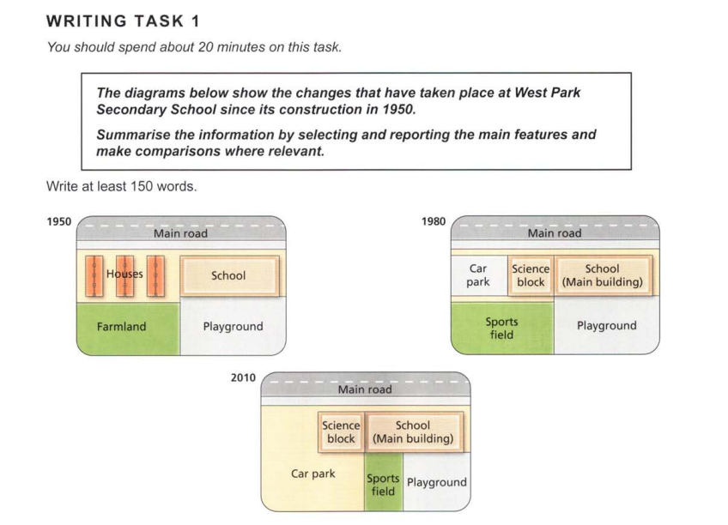

The given diagrams show the changes in the layout of West Park Secondary School since its establishment in 1950, with snapshots of the area from 1950, 1980, and 2010.

In 1950, the school was constructed alongside a few houses, along the main road. There were vast expanses of farmland behind the houses, while a playground behind the school met the needs of the students.

In the next 30 years, the houses were moved or removed, and the school expanded with the construction of a ‘Science block,’ and an adjoining parking area was made for vehicles like cars. The farmland was converted into a sports field, while the playground stayed unchanged.

By 2010, the size of the sports field was drastically reduced, and it was moved to the area South of the main building, thus also causing the playground to shrink. The school buildings appear to have stayed the same since 1980. The car park that used to be a tiny piece of land next to the science block has visibly expanded, taking up most of the space that was farmland 60 years ago.

Hence, the region surrounding the secondary school of West Park, and the school itself, have seen noticeable modifications in the years between 1950 and 2010.